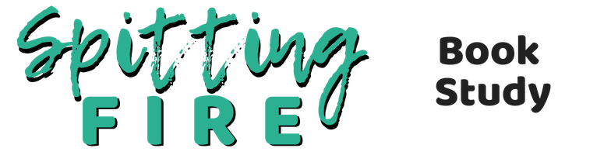
What’s My Motivation?
We get motivated and inspired by tons of things. This exercise is focused on bringing awareness to what motivates you and how it may or may not be working for you.

Fill in the blanks below.
I feel most inspired when I’m feeling ___________________________.
I feel most inspired when I’m thinking __________________________.
I feel most motivated when I’m around ________________ people.
I lose my motivation when ____________________________________
______________________________________________________________.
When I’m in “go” mode, I feel it in my _____________ (body area).
I am self-motivated, when I’m doing __________________________
_____________________________________________________________.
I am reactive, when I’m doing ________________________________
_____________________________________________________________.
My ideal environment to feel motivated looks/feels/smells like
_____________________________________________________________
_____________________________________________________________.

