SpitFire Tetrahedron Self-Assessment

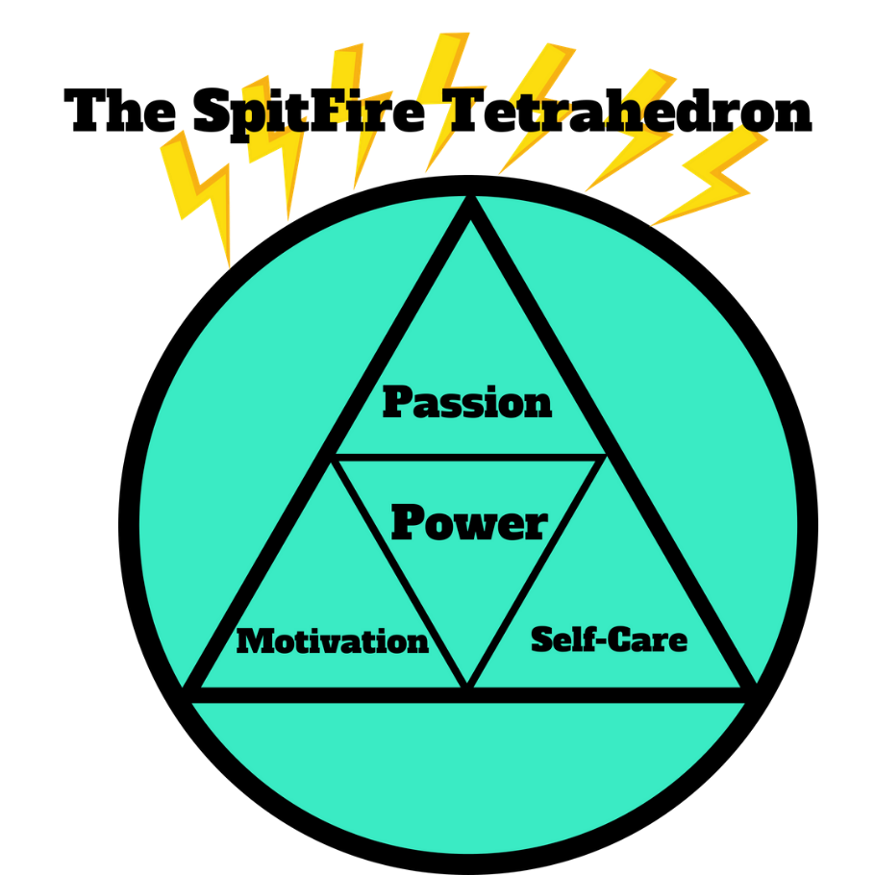
In order to tap into your true SpitFire Power, we gotta make sure all of our elements are in order. In this worksheet be able to determine which (if any) elements are needing some extra attention and tweaking.

Be honest and kind with yourself as you rate each of these sections. We’ll be rating each item on a scale of 1-10 (1-totally disagree, 5- I’m on the fence, 10-totally agree)

Passion
__ I am clear about my passion
__ If I were woken up in the middle of the night and told I could only do one thing, I would know what to do
__ It doesn’t matter what anyone else says, I love what I do
__ When I do this, I feel completely in flow and creative
__ When I do this, other people are naturally attracted to me
__ When I do this, all stress and worry go away
Total number: __________________ Divided by 6 = _____________________________

Motivation
__ Every morning I feel like bouncing out of bed
__ I feel focused and clear on why I do what I do
__ I am clear about what needs to be done and why
__ I am a self-starter
__ I have a clear idea why I’m doing this
__ I am doing this to make me happy
Total number: __________________ Divided by 6 = _____________________________

Self-Care
__ I meditate every day
__ I intentionally move every day
__ I laugh every day
__ I read/write more than twice a week for pleasure
__ I have a self-care practice
__ I believe I am worthy of a self-care practice
Total number: __________________ Divided by 6 = _____________________________

Circle any areas that are lower than an average of 7. These are potential areas of concern that could be impacting your SpitFire Power.

